6th INTERNATIONAL
AUSTRIAN CUP SALZKAMMERGUT
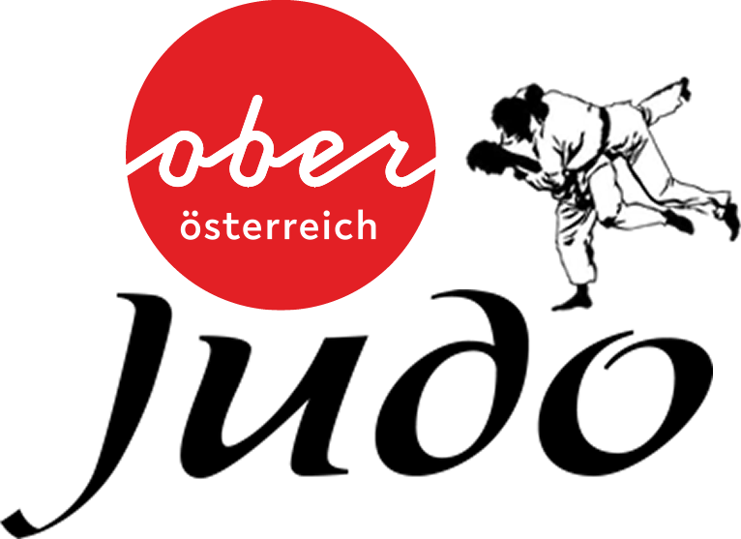

Saturday: March 2nd 2019
WOMEN / MEN U21, U18, U16
Sunday: March 3rd 2019
GIRLS / BOYS
U10, U12, U14
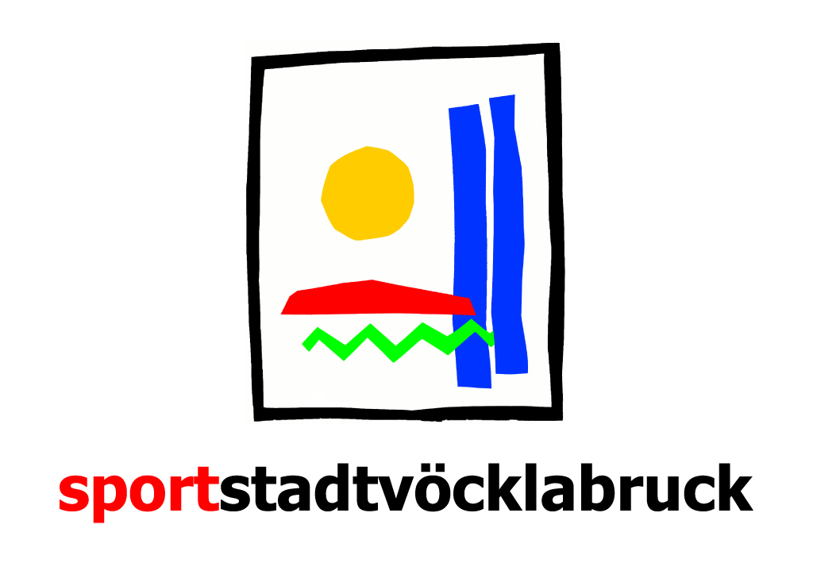
Bezirkssporthalle Vöcklabruck
Bahnhofstrasse 44
A - 4840 Vöcklabruck, Österreich
Judolandesverband OÖ, Waldeggstraße 16, 4020 Linz - ZVR 014103112  Organizing Club: Judoteam Salzkammergut, Chairman Reisinger Manfred  Email: reisinger.manfred@a1.net www.intsalzkammergut.judoteam.at | For more details please contact  Reisinger Manfred  Mobile: +43(0) 676 9183256

Age group | Born | Weight categories | Contest Time | Weighing
Women U21 | 1999 - 2004 | -44/-48/-52/-57/-63/-70/-78/+78 kg | 4 Minuten | Sat. 09:00 - 09:30
Men U21 | 1999 - 2004 | -55/-60/-66/-73/-81/-90/-100/+100 kg | 4 Minuten | Sat. 09:00 - 09:30
Women U18 | 2002 - 2004 | -36/-40/-44/-48/-52/-57/-63/-70/+70 kg | 4 Minuten | Sat. 11:00 - 11:30
Men U18 | 2002 - 2004 | -46/-50/-55/-60/-66/-73/-81/-90/+90 kg | 4 Minuten | Sat. 11:00 - 11:30
Women U16 | 2004 - 2006 | -28/-32/-36/-40/-44/-48/-52/-57/  -63/+63 kg | 3 Minuten | Sat. 13:30 - 14:00
Men U16 | 2004 - 2006 | -34/-38/-42/-46/-50/-55/-60/-66/  -73/-81/+81 kg | 3 Minuten | Sat. 13:30 - 14:00

Age group | Born | Weight categories | Contest Time | Weighing
Girls U10 | 2010/2011 | -20/-22/-25/-28/-32/-36/-40/-44/  -48/+48 kg | 2 Minuten | Sun. 08:00 - 09:00
Boys U10 | 2010/2011 | -20/-22/-24/-27/-30/-34/-38/-42/  -46/+46 kg | 2 Minuten | Sun. 08:00 - 09:00
Girls U12 | 2008/2009 | -22/-25/-28/-32/-36/-40/-44/-48/  -52/+52 kg | 2 Minuten | Sun. 08:00 - 09:00
Boys U12 | 2008/2009 | -24/-27/-30/-34/-38/-42/-46/-50/  -55/+55 kg | 2 Minuten | Sun. 08:00 - 09:00
Girls U14 | 2006/2007 | -25/-28/-32/-36/-40/-44/-48/-52/  -57/+57 kg | 2 Minuten | Sun. 12:00 - 12:30
Boys U14 | 2006/2007 | -30/-34/-38/-42/-46/-50/-55/-60/  -66/+66 kg | 2 Minuten | Sun. 12:00 - 12:30

Weighing for Saturday (U21/18/16) is possible on Friday between 7pm and 7.30pm.
Weighing for Sunday (U10/12/14) is possible on Saturday between 6pm and 6.30pm.
Start of competition after drawing.
Registration via email on the enclosed entry-form to intsalzkammergut@judoteam.at no later than February 27th, 2019- double entry is possible.
The participation fee of € 15,- per judoka and start must be paid in cash at the check-in.
Additional registration on competition day can be done at the registration desk for € 20,-.
Valid passport must be shown at weighing.
The holding of the tournament is a 4-group system (Cup system with enlarged repechage). Should there be less than 6 but at least 2 starter in a weight class, everybody fights everybody. Should there be only 2 starter in a group, the mode is best of three.
Obligation: First player of the age groups U21 and U18 called for a contest must wear a white Judogi. The player called second has to wear a blue or coloured Judogi, but no white one.
U21/U18 and U16 arm locks and strangles are allowed.
U10/U12 arm locks or strangles are not allowed.
Valid competition rules of the Austrian Judo Committee are used.

Winners of each weight category U21/U18/U16 will get cups, second and third places will get medals. Winners, second and third places U10/U12/U14 will get medals or statues.
Competition management: Katja Schneeberger and Gerhard Öhlinger, Computer: Katja Schneeberger.
Cold and hot food and drinks will be offered.
Dinner is offered for 6,-€ (Friday 7pm-7.30pm, Saturday 6pm-7pm).
It is possible to stay overnight in the event hall (8,-€ including breakfast in the hall).
On Saturday and Sunday breakfast will be offered from 8am for 5,-€-.
Registration necessary for dinner, overnight stay in the event hall and breakfast!
For more information or registration contact intsalzkammergut@judoteam.at or visit www.intsalzkammergut.judoteam.at.

For information on accommodation please contact Tourismusverband Vöcklabruck:
A - 4840 Vöcklabruck, Graben 8

Tel: +43 7672 26644 // Mobil: +43 676 84106688 // tourist.voe@asak.at

The organizer assumes no liability for any injuries etc., each participant or club has to take care of their own costs.

Sent to invited clubs in

Algeria, Angola, Austria, Ukraine, Italy, Poland, Slovenia, Slovakia, Netherlands, Great Britain, Czech Republic, Germany, Hungary, Croatia, Rumania, Liechtenstein, Luxembourg, Bosnia, Serbia, Montenegro, Moldova, Switzerland, Belgium, Denmark, Lithuania, Nigeria, Uganda, France and more.
ÖJV, OÖJV, LSO, BSO

Gerhard Öhlinger Manfred Reisinger Gerald Eidenberger
Vice president Judo LVOÖ Chairman JT Salzkammergut President Judo LVOÖ

6th Internatiomal Austrian Cup
Salzkammergut U21, U18, U16
Entry Form - Saturday, March 2rd 2019
Club:
Contact Person:
Phone: E-Mail:
Lfd.  Nr.: | Last name | First name | Born | female |  |  | male |  |  | Weight-  category
 |  |  |  | U21 | U18 | U16 | U21 | U18 | U16
1
2
3
4
5
6
7
8
9
10
11
12
13
14
15
16
17
18
19
20
Mark valid sex
Write clearly
Please respect the deadline for the entries – February 27th 2019
intsalzkammergut@judoteam.at

Date / signature / Club
6th International Austrian Cup
Salzkammergut U10, U12, U14
Entry Form - Sunday, March 3rd 2019
Club:
Contact Person:
Phone: E-Mail:
Lfd.  Nr.: | Last name | First name | Born | female |  |  | male |  |  | Weight-  category
 |  |  |  | U10 | U12 | U14 | U10 | U12 | U14
1
2
3
4
5
6
7
8
9
10
11
12
13
14
15
16
17
18
19
20

Mark valid sex
Write clearly
Please respect the deadline for the entries – February 27th 2019
intsalzkammergut@judoteam.at

Date / signature / Club

